GET and POST

1. **Creating dynamic web project**

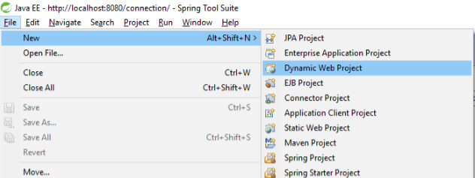

1. **Project Structure**

Place all your java classes in “src” directory and all jsp files in Yourproject-->WebContent-->WEB-INF--> jsp.

We Can also create our Own folders in WEB-INF with respect to project Requirement.

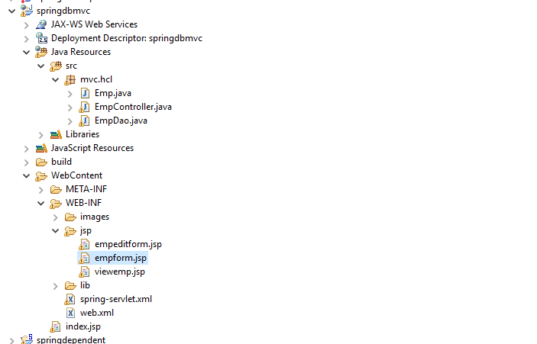

1. **In WEB-INF copy all jar files in lib folder and give required server libraries if need**

Here I am added related to GET and Post Methods.

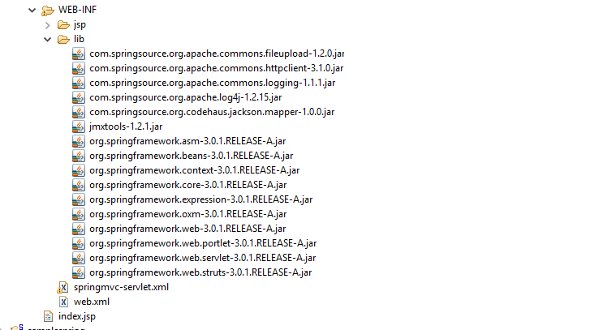

1. **Java classes**

1)Employee class :

Note: In this keep all required fields and create getters and setters.

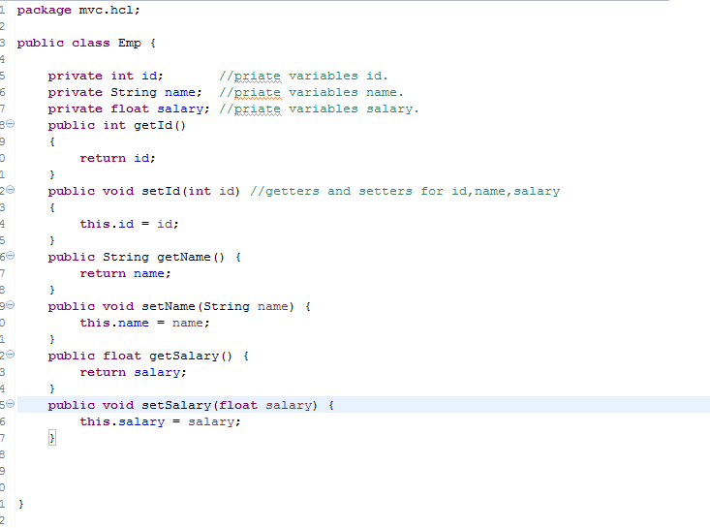

2)Empcontroller class

Note: In controller class mainly we use RequestMapping, it will map to the specified jsp page (view).

The **@Controller** annotation is used to mark any java class as a controller class.

The **@RequestMapping** annotation is used to map the web request "index" to the Controller class.

See in the snippet “***RequestMethod.POST***” That should be same like a “***jsp page Method Post***”

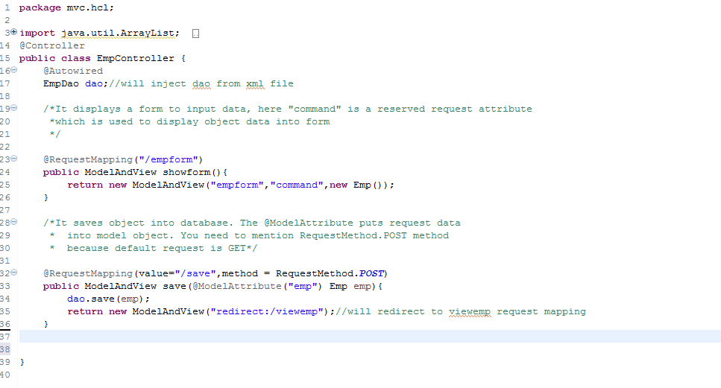

3) Employee DAO class:

**Note**: As Shown in the Snippet in DAO should mention “Queries” related to DataBase

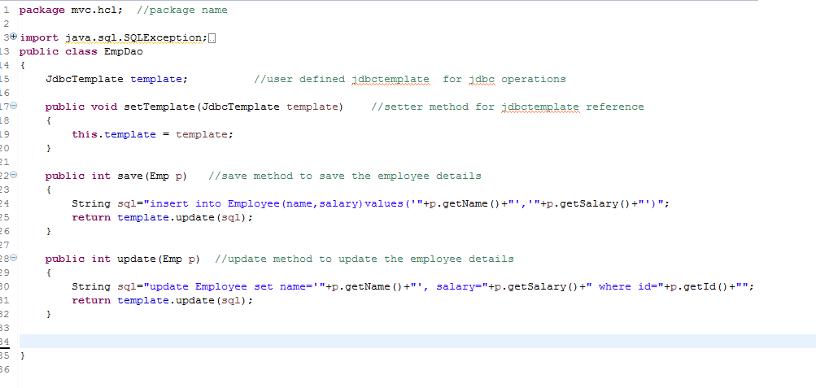

5. Jsp pages

1)Empform

**Note**: in this page Spring form tags are used. Method as used as ***POSt.***

By using post our information will be ***secured.***

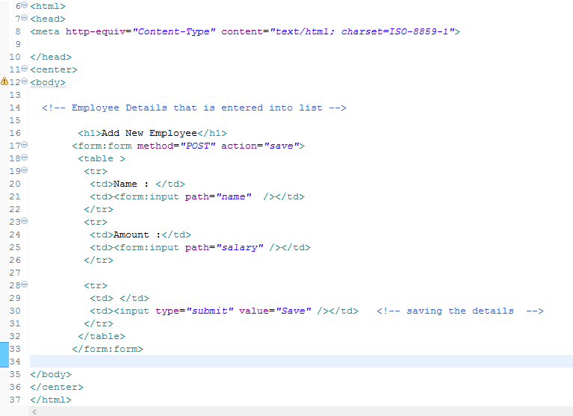

2)ViewEmp

In this snippet just printed the Employee added info.

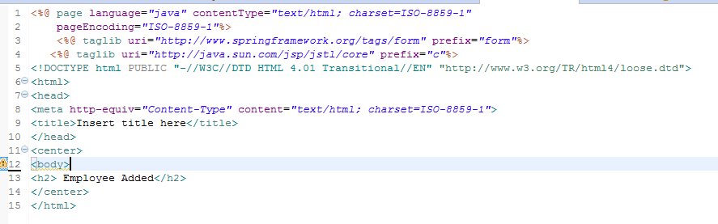

6)Web.xml

In this snippet imp thing is DispatcherServlet.

It will take care about flow of the program.

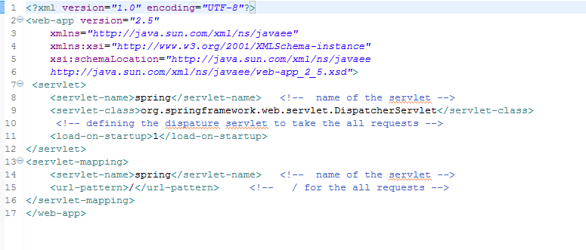

7)spring-servlet.xml

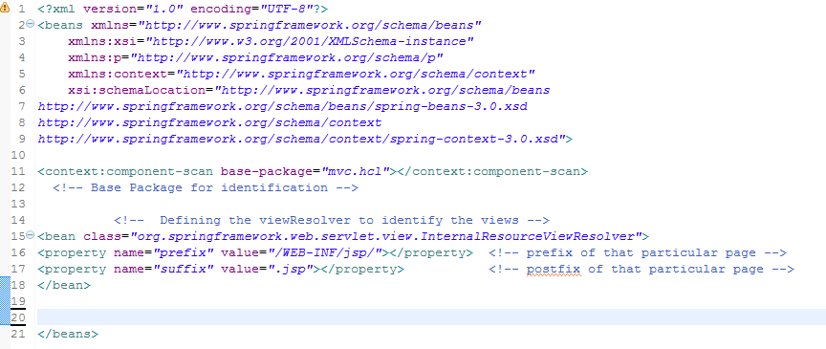

8) Note:

**GET:** If we use ***Method:GET*** in the jsp page then in controller class also should use ***Requestmethod.GET***

Then in OutPut it will display in the address bar our entered fields also.

It will not ***Secured***

See Below Snippet

D:\Users\chodi.b\Pictures\Screenshots\Get.png

**POST:** If we use ***Method:POST*** in the jsp page then in controller class also should use ***Requestmethod.POST***

Then in OutPut it will not display in the address bar our entered fields also.

It will be ***Secured***

See Below Snippet

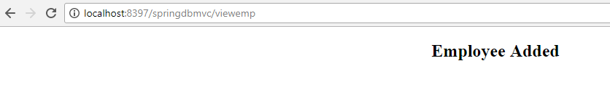

**OUTPUT**: In the above Example code Used Post method

